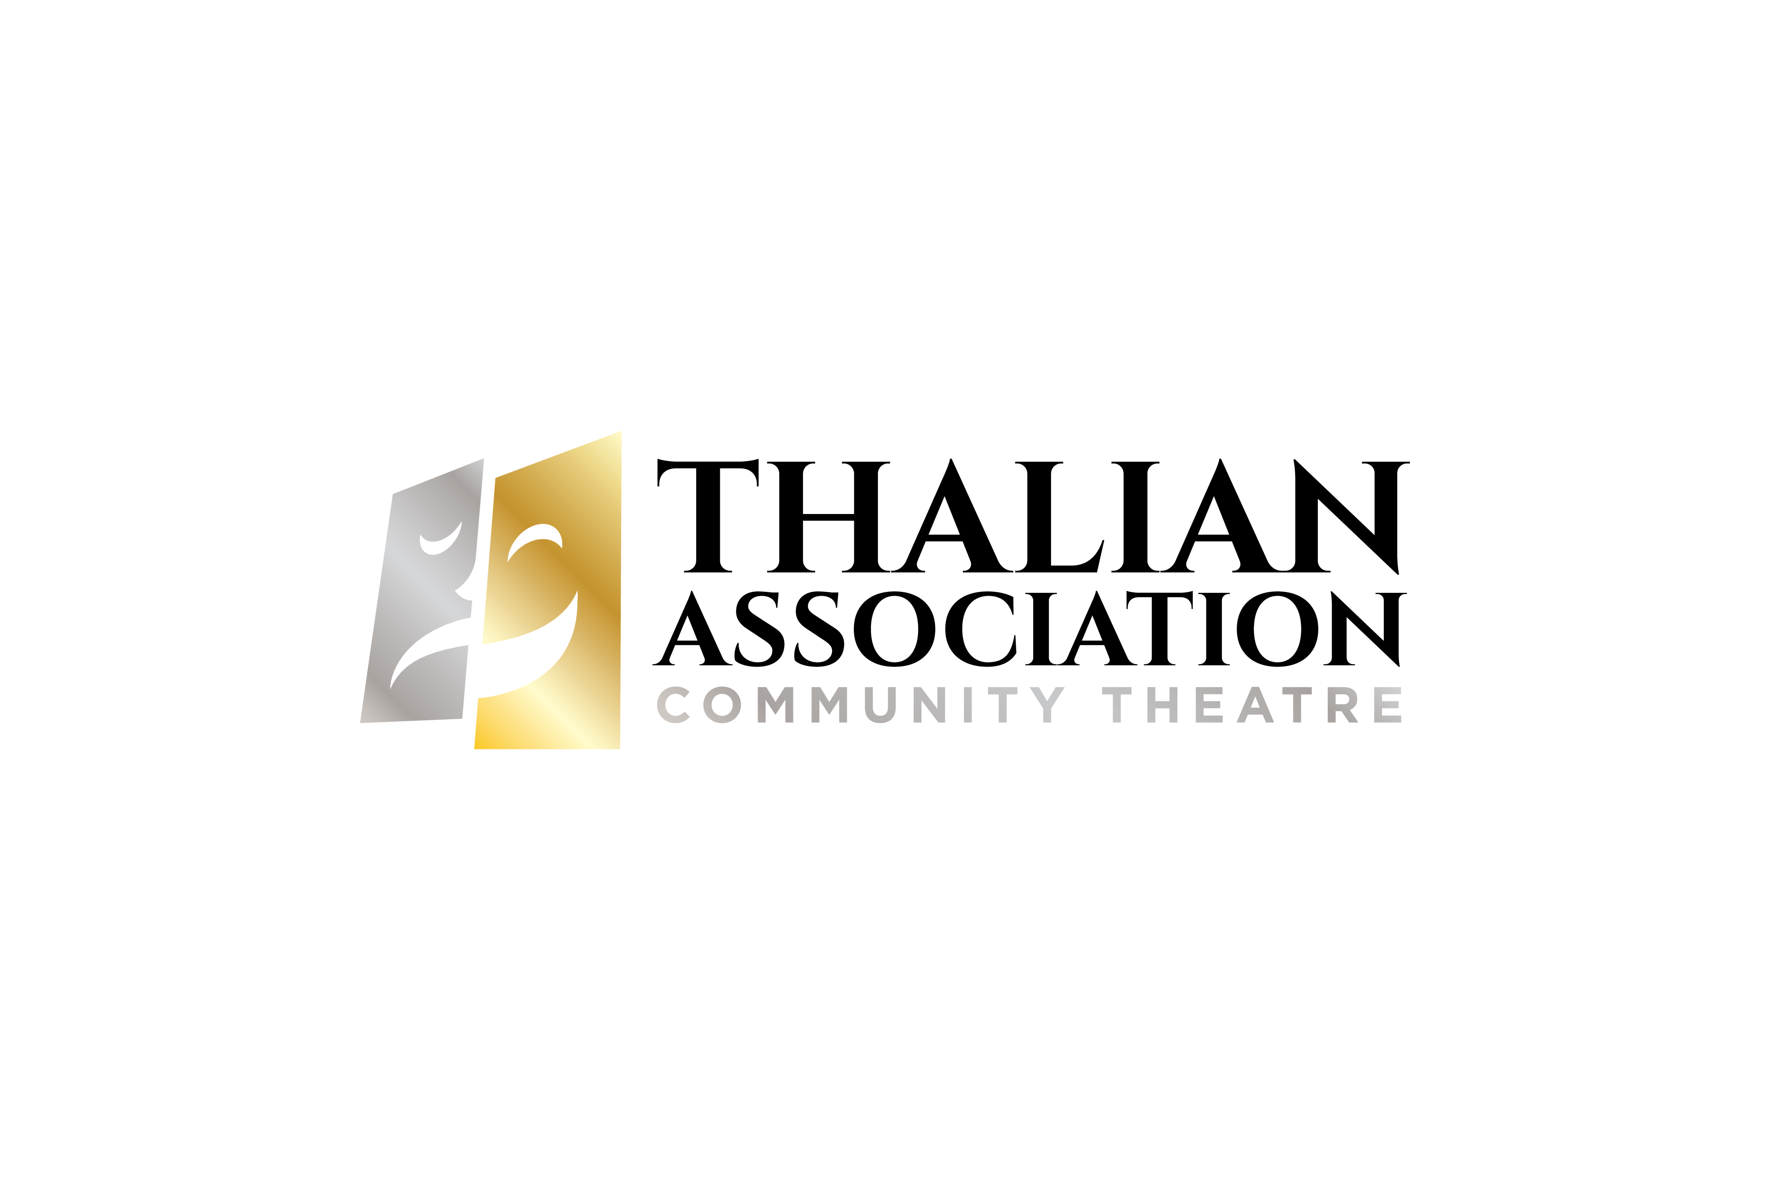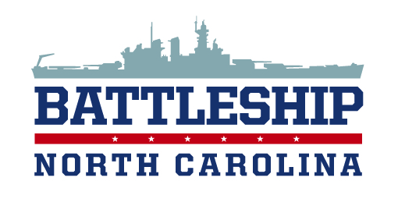

FOR IMMEDIATE RELEASE

CONTACT:

Susan Habas

Thalian Association Community Theatre

910-251-1788

shabas@thalian.org

**LIVE THEATER RETURNS TO THE BATTLESHIP NORTH CAROLINA**

***Caine Mutiny Court-Martial***

WILMINGTON, NC – Thalian Association Community Theatre is pleased to provide another opportunity for the community to experience live theatre on the fantail of the Battleship Memorial. *Caine Mutiny Court-Martial* will open June 29th and run for ten performances, Friday – Sunday at 8 pm until July 15th. There will be a special 7 pm performance on July 4th followed by the City of Wilmington fireworks.

“Last summer Thalian Association and the Friends of the Battleship NORTH CAROLINA made history with *Mr. Roberts*, the first production on the fantail”, said Susan Habas, Executive Director of Thalian Association Community Theatre. “The public reaction was so enthusiastic and supportive that we immediately started looking for another production to give folks a second chance to see a show on this historic ship.”

*Caine Mutiny Court-Martial* is based on a Pulitzer Prize novel by Herman Wouk. This thought-provoking two act play chronicles the court martial of the lieutenant who commandeered the U.S.S. Caine during a potentially deadly storm. The only way his attorney can save him is to prove that Captain Queeg was mentally incompetent to safely run the ship. The play covers only the court-martial itself and like jurors at a trial, the audience knows only what various witnesses tell of the events on the *Caine.*

*Caine Mutiny Court-Martial* will be the local directorial debut of Jordan Wolfe, a veteran of community theatre productions across the country and the head theatre professor at Coastal Carolina Community College. Local audiences may recognize Jordan from recent Main Stage Thalian Hall appearances in *Peter and the Starcatcher* and *Young Frankenstein.*

“I am so excited to bring the Caine Mutiny to life on the fantail of the Battleship Memorial”, said Jordan Wolfe. “Staging a show on a ship is a rare opportunity and I hope to have some of my students intern for the technical and production teams.”

Tickets for all shows are now on sale at [www.thalian.org.](http://www.thalian.org.) Regular show prices range from $30 for adults, $25 for seniors, $15 for children and $15 for retired and active military. Special ticket pricing for the July 4th performance are $50 adults/$25 children and include a grand view of Downtown Wilmington’s Fireworks display. Special group rates apply for parties of 12 or more.

**About Thalian Association Community Theatre**

Established in 1788, Thalian Association Community Theatre is a non-profit, membership organization dedicated to enhancing the Cape Fear region through live community theatre and arts education. Thalian Association Community Theatre produces five major productions annually on the Main Stage at historic Thalian Hall and professionally manages the Hannah Block Historic USO/Community Arts Center for the City of Wilmington. The youth theatre program offers training and performance opportunities for children age seven through high school seniors. In 2007, Thalian Association Community Theatre was designated North Carolina’s Official Community Theater by the state legislature. For more information, go to [www.thalian.org.](http://www.thalian.org./" \t "_blank)

###

